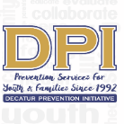

COALITION MEETING

May 9TH, 2023

NOON to 1:30 pm.
Please put your name and your affiliation in Chat
- WELCOME WITH VISION AND MISSION
Vision-Promote a healthy Decatur, free of the negative effects of alcohol and other drugs on youth and families. Mission- Systematically implement evidence-based strategies to promote the behavioral health of youth and families.
- Introductions-Name, Agency Affiliation, Sector-Reminder
Meredith McCoy (Parent), Gary Menard (Health), Duane Sprull (Schools), Brian DiNapoli (Faith), Juan Navarrete (SA Prevention Organization), Lartesha Chaney (Youth Serving Agency), Susan Morley (DPI), Marnie Grodzin (DPI), Dee Anderson (DPI), Carol Treible (DPI), Tiffany Cuthbert (DPI), Ashley Watson (DPI), Terrie Moore (DPI)
- National Fentanyl Awareness Day -Marnie
Marnie Grodzin and Ashley Watson- DHS event for Mental Health Awareness week-Showed the video developed by Charlie Songs during the lunch periods. Students were able to watch the video and enter into a raffle. The students reacted positively to the video; some even returned to watch it with friends. Here is the link for the Fentapill Video- https://youtu.be/f8GZ264ND78
- Have you completed the Coalition Effectiveness survey?
Once you complete the survey, please email us to let us know and to be entered into the raffle. Please access the survey at https://www.surveymonkey.com/r/DPICoalition
- Other Upcoming Collaborations-
  - Career Academy Health Experience (Rising 9th-10) Summer Camp - July 10⁻ 14 Others
    - Duane Sprull – Ms. Smiley and Nurse Shonda were in the lead, while Mr. Sprull served as interim role principal. Terrie is meeting with the planning team. The team is excited that the Summer Camp goes beyond just health and focuses on mental health. The team has several college tours planned. Duane will discuss with Terrie offline about pivoting to utilize additional funds.
  - Housing Authority
    - Lartesha Chaney –Excellence Awards are happening on May 24th at 5 PM. Working to coordinate this event and currently looking to recruit two volunteers to help with the event. DPI will supply the bookbags for the 16-17 students, and Terrie will coordinate getting them to DHA. Marnie Grodzin has volunteered from DPI. Ms. Dee will check with the CMAT's parents. Gary Menard asked for an email about the volunteer opportunity.
      - LIT Training- May 31st- June 2nd - Currently have 17 candidates for the leadership in training sessions and is the largest number of registrants that DHA has received; however, they currently only have funds to cover six positions. Lartehsa hopes to find a way to take them all as they all say that this is how they want to spend their summer and gain the needed work skills. She is reluctant to turn away any youth, so she is looking into scholarships currently. The program also provides the foundation for the workforce the following year.
        - Terrie Moore suggested reaching out to Stacey Stevens for more youth opportunities.

- -STOP Act: Targets for 12-20 (Alcohol ONLY) Support from Ashley Watson and Ladarious Brown
  - Graduating Senior handbook for DHS and ASC-Terrie
  - College Action Team Training Report: Carol
    - Terrie Moore- Hosted and trained DPI's first College Action Team in the Strategic Prevention Framework (SPF). DPI was very excited to get the MOU with the Agnes Scott Campus
    - Carol Treible- DPI spent Saturday, April 15^{th,} with five Scotties. The students were very involved and supportive of starting a College Action Team on the ASC campus. The students completed a pre-test and post-test on the SPF model. Michael from GUIDE developed the SPF presentation, and Terrie Moore presented on Positive Social Media. The evaluations were very positive. The students were interested in continuing their involvement, engaging the LGBTQ community, and promoting and informing prevention efforts on social media and throughout the Campus. They also expressed interest in educating their peers on substance abuse/misuse prevention and inviting other peers. They discussed connecting over the summer while away from Campus, highlighting a commitment level. They were interested in learning some of the statistics on drugs and alcohol on the Campus. DPI has conducted a campus-based survey and is seeking IRB approval to conduct another in the Fall. DPI will share ASC data with the students. DPI perceives a long partnership.
  - DUI events
    - The DPI team postponed Cinema Drive until early Fall. DPI wants to collaborate with Duane Sprull (DHS) and incoming Scotties. Terrie is working with the representative to get this for the community.
  - PSA-
    - Honor Court Video 17,247 Impressions
  - Sticker Shock campaign w/College Action Team-Fall
    - The College team will be working with all ten alcohol retailers within the City of Decatur.
  - Additional-
    - DPI hopes to have the students create posters for the dorms, which will welcome the students and speak on underage drinking.
- Partnership for Success 14-24 (Alcohol & Illegal Drugs)-thru Sept 2024
  - PreVenture (10 groups-108 invited to participate)
    - DPI completed PreVenture for the school year
- ASC Survey Report completed- IRB preparing for submission.
- Deterra Distribution @ YMCA –
  - DPI gave out over 100 bags to the community during the YMCA event.
- Harm Reduction? Drink covers, etc.
LGBTQ+ Community
- Drug-Free Communities 9-18 (Alcohol, Nicotine, Marijuana)-Thru Sept 2024
- Last Year-ends Sept. 2024-
  - DPI needs new MOUs from all Coalition Members to re-submit for DFC funding
- CMAT Recent & Upcoming Events-Dee
- Talk They Hear You PSA before spring break – Instagram
  - https://www.youtube.com/watch?v=bLmq4VnF6qU
- Parent Network-Screenagers: Under the Influence-Vaping Drugs and Alcohol in the Digital Age-
  - Thank you to the DPI coalition members for getting the word out about this event. All hands were on deck with making this event happen. DPI had 290 registered on Eventbrite - with 120 in attendance. Thanks, Mr. Sprull, for your help with getting the facility and the caterers.
- Just Not Worthit DPI marijuana prevention-focused video - Snapchat
  - Geo-targeted for 4/20
- YAT-Members Report-
  - Marnie Grodzin- Wrapped up for the school year, the last main event was last Wednesday, May 1st, when the YAT put together an event before testing began.
    - Participants entered a raffle, and Marnie will contact the winners tomorrow
- EBP-All Stars (round 3)-
  - Marnie Grodzin- Wrapping up two more visits with two 7th-grade classes
- Prevention Plus Wellness (all DHS health classes-April)-Susan
- Focus Articles for DPI and Network - Volunteers Needed
- At-A-Glance Evidence-Based Programs-"
- Safe Homes "Decatur Parents Network."
- All Stars-7th grade Wellness Class-Marnie
- Prevention Plus Wellness 9th-Susan
- Susan Morley- Evidence-based program for the schools, DPI focused on Vaping, marijuana, and alcohol through the sports program. The program aims to inform the youth of the risks. It discusses goals and how these substances can interfere with a healthy and active lifestyle. DPI has not received the results from the most recent surveys, but once we receive them, DPI will share them. DPI served five different classes this semester.
- This Is Not About Drugs
- PreVenture-Screening-Can We Expand?
- Parent Handbook for Graduating Seniors (Penn State version)
- Terrie- The goal is to get this handbook out to all graduating seniors and incoming first-year students in the Decatur area. This evidence-based handbook shows its effectiveness in talking to your youth about these issues immediately upon graduating. Terrie will work with Duane Sprull to get the initial email to the parents to build anticipation for the release.
NEXT MEETING: June 13th @ 12:00

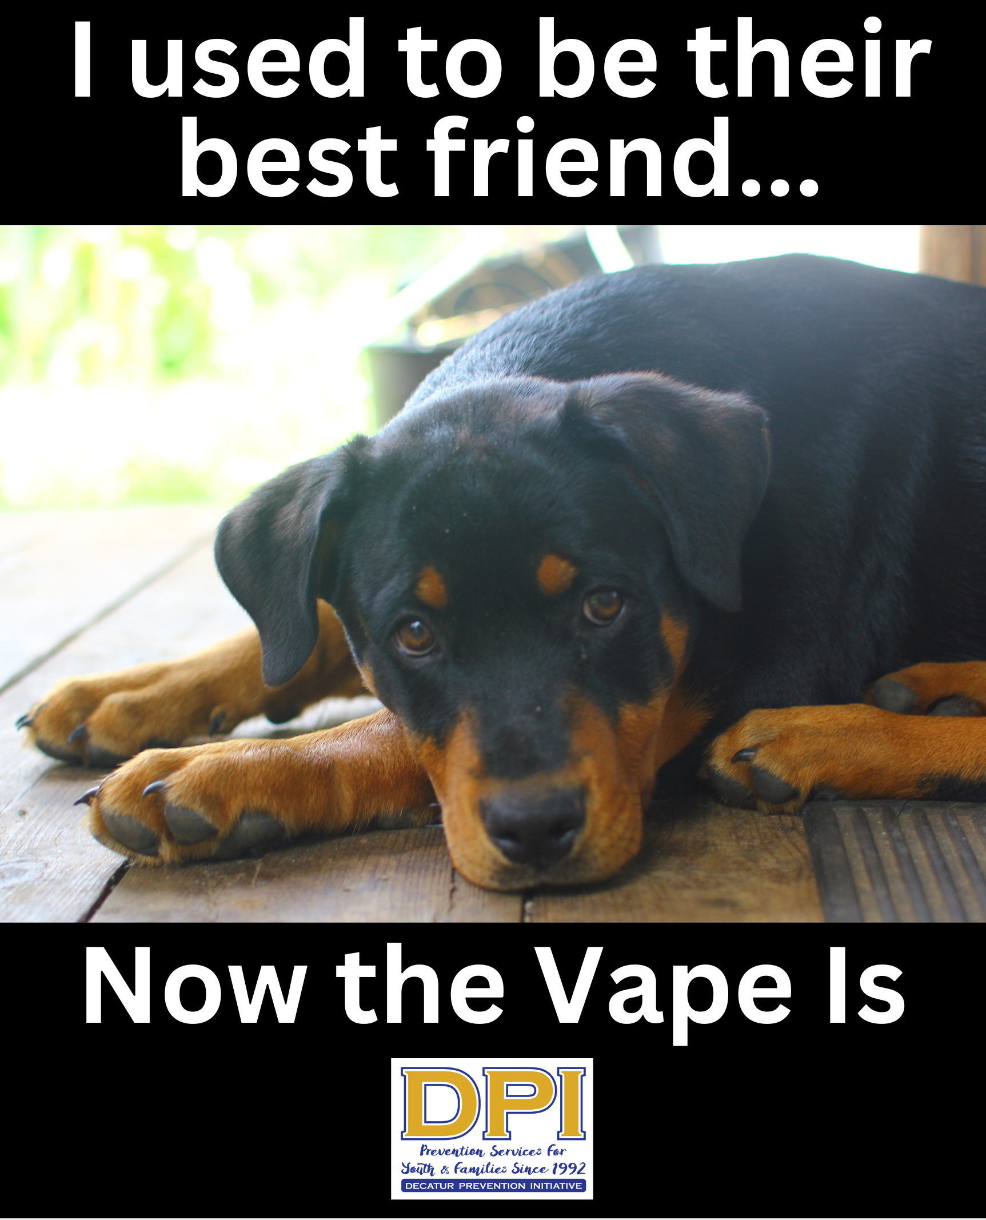
Developed by YAT member Justice (with MG support), Geo-targeted with Snapchat later this month.

Parent Teen Partnership Handbook

Table of Contents

Introduction ....................................... 7
Improving Communication in General ................ 8
Communication Pointers ............................ 10
The Initial Conversation ............................. 11
Communication: The Short Response.................. 12
Developing Assertiveness ............................ 13
Talking About Alcohol............................... 14
How Alcohol Works in the Body ...................... 15
Why Students Drink................................. 17
Why Students Do Not Drink.......................... 19
Binge Drinking: Drinking to Get Drunk ............... 21
Did You Drink When You Were a Student? ............. 23
For More Information ............................... 25

